St. ANTHONY’S COLLEGE
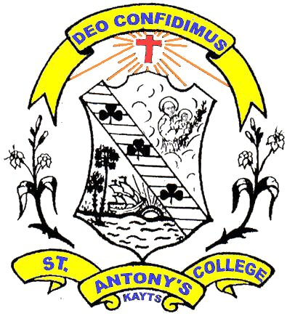
Kayts
140th Anniversary Celebration
fhtYhh; Gdpj me;Njhdpahh; fy;Yhhp
140tJ Mz;L kyh; ntspaPl;L tpohTk; tUlhe;j xd;W $lYk;
Organized By: St. Anthony’s College Kayts
Alumni Association Canada
fhtYhh; Gdpj me;Njhdpahh; fy;Yhhp
gioa khzth; rq;fk; fdlh

Guest of Honour: Rev. Fr. K. James Singarayer
(Rector, St. Anthony’s College, Kayts)

Chief Guest: Dr. George Pillainayagam
(Professor, Lorain County Community College, Elyria, Ohio)

Special Guest: Dr. Chellaiyah Rajalingham
(Professor, Concordia University, Montreal, QC)
Date: December 08, 2012
Time: 6:30 PM
Venue: J & J Swagat Banquet Hall
(Warden & Denison)
415 Hood Road, Markham, ON., L3R 3W2
Tel: Cyril 905-947-4414 Emilian 416-283-4725
Eugene Dominic (647) 388 4038
Email: sackaacan@gmail.com
Web: www.kayts-sac.com
Map

